Nursery
Welcome
Pack

Dear Parents,

We are delighted to welcome you and your child to our nursery.
We aim to provide an experience that will not only be very valuable but full of enjoyment at this very special time in your child's life.
Starting nursery can be a very anxious time - for parents as well as children! We hope that you feel able to share any concerns you may have and ask any questions - we are happy to help now and after your child has started with us.
This booklet aims to answer some of the questions you may have about what your child will do at nursery and why.
We look forward to getting to know you and your child over the coming terms,

Thank you,
The Nursery Team
Useful Information
Induction -
You will receive a letter with your child’s own individual starting date for their first day at nursery. The children do not all start on the same day, so that staff can give extra attention to your child on that very important first day.
Times -
We run two sessions - one morning session from 8.30am until 11.30pm and one afternoon session from 12.30pm until 3.30pm. We also offer full time places 8.30am – 3.30pm (for those children entitled to the 30 hours government funding. The code for this must be applied for after 15th June for sept start – the code then needs to be given to the school office by the first week in July) If you are offered a full day place you will need to send your child with a packed lunch and pay the additional hour child care fees at the beginning of each half term. Details of our school Scopay system will be given to you as soon as your child starts.
What your child will need -
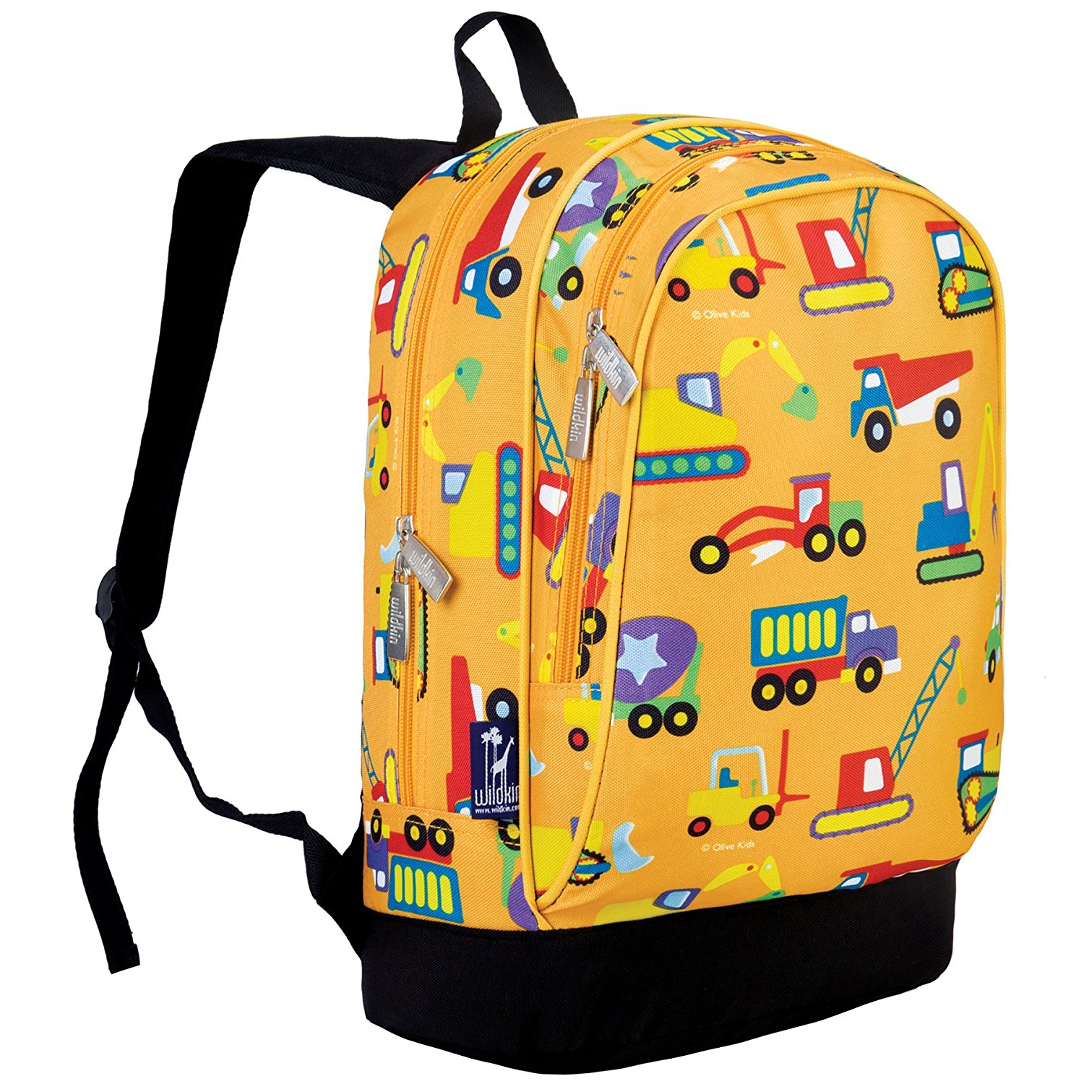
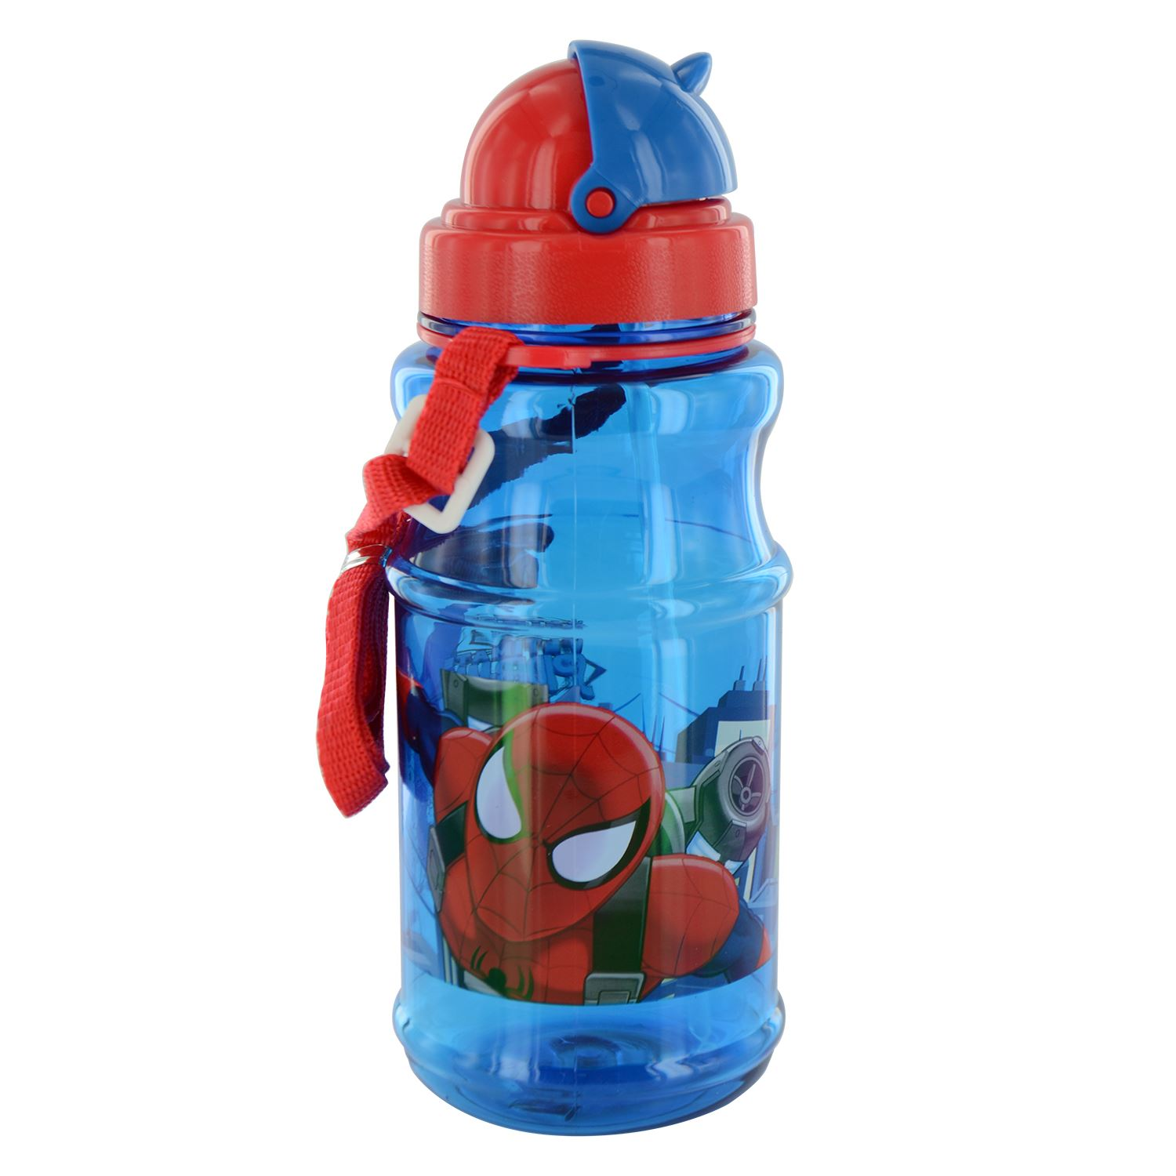
When your child starts Nursery they will need to bring with them daily a named bag with a complete change of clothes inside. (Trousers, socks, pants, t shirt and jumper) Sometimes your child may have an accident or get wet playing in the water etc. We do have a few spare clothes but it is nicer for your child to have their own clothes.
Your child must also bring a named water bottle.
Please make sure your child wears practical clothes that they can manage themselves i.e. No belts, laces, buttons etc. and has suitable clothes for the weather as children always have an opportunity to go outside e.g. Sunhats, wellies, warm coats, waterproof coat, gloves, scarves and woolly hats.
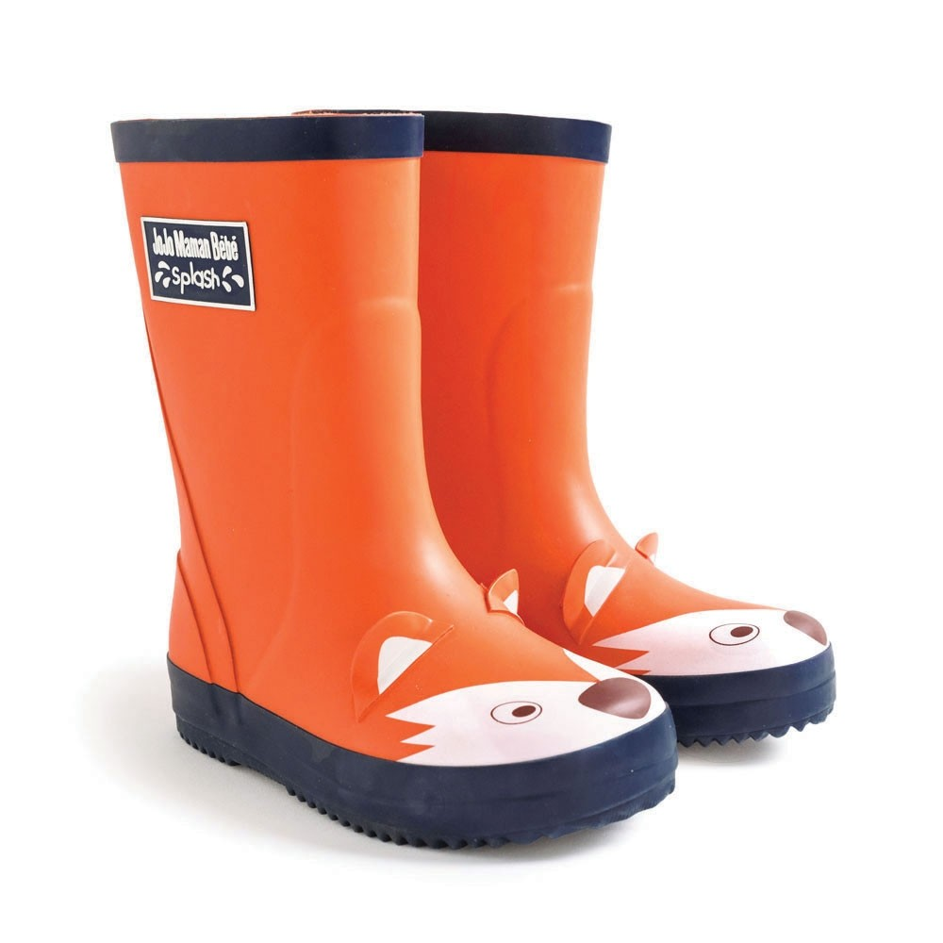
Your child needs their own pair of named wellies all year that they can leave in Nursery (we always change into these to go in the garden, whatever the weather)

Your child will also need a pair of waterproof trousers as Wednesdays we have an outdoor learning day and we spend the whole day outside. During the winter months you may want to layer your child up on this day.

Work Boxes –
When your child starts nursery, he or she will have a “work box” which stays in nursery, the work box will have a photo of your child on the side so they know which box is theirs. The box is not only for work and products your child has made but any information we need to send home to you. The boxes enable the children to become independent in looking after their own work and belongings. Children will bring these letters/pictures home either daily or on a Friday in their book bag.

Home Learning Book -
Once your child has settled into Nursery we will start up a home learning book. This is to help you to find out more about the things we are doing in Nursery and how you can support your child at home. You can also record any information you would like to share with us about your child.
This book gets sent home on a Friday and needs to be back by Wednesday the following week.

Uniform - Nursery does not have a uniform but colourful T-shirts and sweatshirts with the Nursery logo on are available to be ordered through the school’s ScoPay system details will be given as soon as your child starts. Children often like to wear them to be the same as the adults, also it saves your child’s own clothes from getting messed up.

Preparation for nursery – If you have any concerns, please speak to a member of staff. Helping your child to start to develop self-help skills will ease transition to nursery. The following list of useful skills will really help the children be as independent as possible:
- Putting on and doing up my own coat
- Taking off and putting on my own shoes
- Going to the toilet myself and wiping my bottom
- Knowing when and how to wash my hands
- Drinking from a cup without a lid
- Peeling and eating whole fruit
- Being able to wipe my nose
- Following simple instructions
- Being able to sit and listen to a story

Library –
We have a library in school which the Nursery children visit once a week. Books are available for the children to borrow for the week.
We ask parents to purchase a book bag from the office so books do not get damaged being transported to and from home.
Books may not be borrowed without a book bag and we do ask that any lost or damaged books are replaced or paid for.


Illness –
Please contact the school office with a message if your child is absent due to illness. In the case of vomiting or diarrhoea your child should not return to nursery until 48 hours without symptoms.

Access –
Your child must be collected by someone known to nursery. Please leave details of changes to normal routines.

Birthdays –
We celebrate birthdays in nursery and parents are welcome to bring in wrapped sweets for their child to share with the other children.

Snacks –
Milk and fruit are provided free of charge. All day children will get fruit in the morning but please provide a whole fruit that can be eaten at afternoon snack time. (This needs to be named and placed in basket in the cloakroom)
Please bring in a small, named, bottle of water for your child every day, for them to have access to at all other times. Keeping hydrated is essential for learning and concentration.



Early Years Foundation stage profile –
We begin collating information about your child's achievements and progress in an individual record box. The information collected in the boxes is made up of photos, pieces of work, notes of what the children have said and done, and also information from parents. The record boxes are located in the small music room where your child enters Nursery, we will arrange some times when parents are able to look through their child’s box, however, please do not remove any contents. We will sometimes send these records home for you to look at also. Parents are encouraged to add notes or photos to the information so that there is a reflection of the child at home and at school. Staff observe the children playing and make notes of what they do and say, this information is used to make assessments to go into an Early Years Foundation Stage Profile document before the children enter year one at school. The document is shared with parents at the end of the foundation stage.

Admissions-
Children admitted to the nursery are not automatically admitted to school. Contact your local education authority to find out about school admissions.

End of Term -
The nursery is closed on the very last day of the Spring and Summer term, This is to enable staff to carry out training and open days for the Nursery. (This does not apply to each half term break.)

News -
The school send out a newsletter every Friday. Nursery news is usually contained in this. The newsletter is now emailed out to parents, if you do not have access to email please let the office know and a copy will be printed for you. Please inform us if you are not receiving a weekly newsletter. Any other letters that nursery send out will be put in your child’s workbox/book bag. Look out for notices we may put up or text messages sent as reminders. Also information is given in your child’s home learning book.
Parent Meetings -
We offer opportunities for parent and teacher meetings to discuss the progress of your child at least twice throughout the year. If you would like to speak to a teacher at any other time we are happy to make an appointment for you, please just ask a member of staff.

Class Bears -
We have two class bears. They love to visit the children’s houses for the weekend and spend time having fun. The bears each have a diary for you to keep a record of what happens during the visit - your child can then share this with their friends at nursery on its return. The bear goes home on a Friday to be returned the following Monday. All children will get a chance to take the bear home throughout the year.

Nursery procedures -

If you have any concerns or issues in Nursery at all please speak to the Nursery Teacher, Mrs Macdonald. If you are unable to do this for any reason or you feel unhappy with the outcome, please then speak to our head of foundation stage Mrs Austin. You can go to the school office or phone the school to make an appointment to speak to her.

How to help at Home

We know that children learn most effectively through play and through real experiences. At home, as the children spend time with parents helping around the house, going out on shopping trips, gardening, playing and talking, there is a wealth of learning experiences going on all the time. The following lists will help you focus on how you are helping your child to learn early skills and concepts in real life situations.

Developing Language and Literacy at home
- Sharing stories, rhymes, songs and poems, recall what happened and ask questions, talk about the pictures
- Following simple instructions in everyday routines
- Modelling language as you play alongside your child
- Looking at words around us – shop names, street names
- Alphabet friezes, songs and rhymes
- A range of books, fiction and non-fiction
- Visit the library
- Using pencils, chalks, crayons, paints to draw, write and scribble, following patterns
- Writing together – lists, cards, messages in everyday routines
- Talking, listening, asking questions
- Music and sounds, making sounds and letter sounds
- Listening to environmental sounds – going on a sound walk ‘what can you hear?’
- “I spy” or “I hear” games
- Talk about new words and explain what they mean
Developing Mathematics at home
- Counting opportunities – count how many stairs as you go to bed
- Encourage comparison as part of everyday routines – the tallest, longest, biggest
- Noticing sets of objects – there are 4 plates on the table
- Sorting objects into colours
- Prediction – which will be heaviest?
- Making sets of numbers - put 5 apples in the bag...
- Simple addition and subtraction – we’ve got 2 apples let’s add two more...
- Making patterns
- Ordering things – let’s start with the tallest...
- Building with construction toys
- Sorting opportunities – sorting washing, matching pairs of socks
- Describe position – inside, next to, behind...
- Looking at and naming shapes in the environment

A few fun family activities which help develop early language, literacy and mathematical skills (and a whole lot more......)
- Build a den together
- Bake a cake together
- Make a film/video together
- Plant some seeds together
- Compile a photo album
- Shopping
- Wrapping presents and writing cards
- Singing Nursery rhymes on a car journey
- Playing “I spy” in the car
- Going on a bear hunt
- Having a shape hunt, letter hunt or number hunt on the walk to school
- Building models out of reclaimed materials (cereal boxes etc.. )
- Chalk numbers, letters and pictures on the ground; “hopscotch” and “corners” games

Useful numbers

- Earley St. Peter’s School office: 0118 9261657
- Wokingham School’s Admissions Team: 0118 9746000
- Wokingham Borough Family Information Service : 0118 908 8002
(Child protection and family support)
- The children’s Society 0300 3037000
- Wokingham Borough Children’s Centres:
0118 9088152 (Ambleside) Woodley
0118 9088010 (Brambles) Wokingham
- Brighter Futures for Children : 0118 937 3641 (Reading)
- Berkshire Autism Society: 0118 9594594
- Promise inclusion (Wokingham MENCAP): 0300 777 8539
- Homestart: 0118 9560050

For advice/information about Speech and Language
Lots of information on the CYPIT website – https://cypf.berkshirehealthcare.nhs.uk/our-services/children-and-young-peoples-integrated-therapies/speech-and-language-therapy/
On this site there is a referral form.
you can also email the team:
Reading – ADMINREADING@berkshire.nhs.uk
Wokingham– ADMINBRWOK@berkshire.nhs.uk
Ican is another good website for information
https://speechandlanguage.org.uk/information-and-support/

